- Given a Binary Tree with distinct nodes. Given two nodes node1 and node2, check if the two nodes lies in the same subtree of the root node. That is, either of the left and right subtrees of the root node.
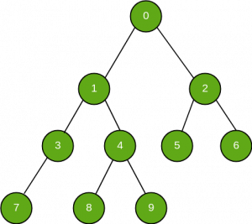

Solution:

static boolean ifNodeExists( Node node, int key)
{
if (node == null)
return false;

if (node.data == key)
return true;

/* then recur on left subtree */
boolean res1 = ifNodeExists(node.left, key);

/* now recur on right subtree */
boolean res2 = ifNodeExists(node.right, key);

return res1 || res2;
}

static boolean ifSameSubTree(Node root, int node1, int node2)
{

if (root == null)
return false;

// CASE 1: If both nodes are in left subtree
if (ifNodeExists(root.left, node1)
&& ifNodeExists(root.left, node2)) {
return true;
}

// CASE 2: If both nodes are in right subtree
else if (ifNodeExists(root.right, node1)
&& ifNodeExists(root.right, node2)) {
return true;
}

// CASE 3 and 4: Nodes are in different subtrees
else
return false;
}

- Given a binary tree and a node, print all cousins of given node. Note that siblings should not be printed.

Solution:

static void printCousins(Node root,
Node node_to_find)
{
// if the given node
// is the root itself,
// then no nodes would
// be printed
if (root == node_to_find)
{
System.out.print("Cousin Nodes :" +
" None" + "\n");
return;
}

Queue<Node> q = new LinkedList<Node>();
boolean found = false;
int size_ = 0;
Node p = null;
q.add(root);

while (q.isEmpty() == false &&
found == false)
{

size_ = q.size();
while (size_ -- > 0)
{
p = q.peek();
q.remove();

// if current node's left
// or right child is the
// same as the node to find,
// then make found = true,
// and don't push any of them
// into the queue, as we don't
// have to print the siblings
if ((p.left == node_to_find ||
p.right == node_to_find))
{
found = true;
}
else
{
if (p.left != null)
q.add(p.left);
if (p.right!= null)
q.add(p.right);
}

}
}

// if found == true then the
// queue will contain the
// cousins of the given node
if (found == true)
{
System.out.print("Cousin Nodes : ");
size_ = q.size();

// size_ will be 0 when
// the node was at the
// level just below the
// root node.
if (size_ == 0)
System.out.print("None");

for (int i = 0; i < size_; i++)
{
p = q.peek();
q.poll();

System.out.print(p.data + " ");
}
}
else
{
System.out.print("Node not found");
}

System.out.println("");
return;
}

- Find the distance between two keys in a binary tree, no parent pointers are given. The distance between two nodes is the minimum number of edges to be traversed to reach one node from another.
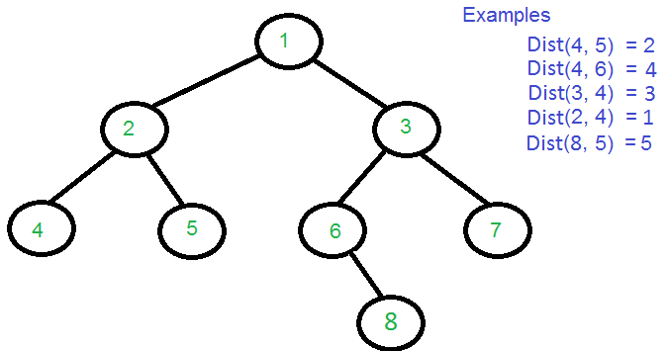

Solution:

public static Node LCA(Node root, int n1, int n2)
{
if (root == null)
return root;
if (root.value == n1 || root.value == n2)
return root;

Node left = LCA(root.left, n1, n2);
Node right = LCA(root.right, n1, n2);

if (left != null && right != null)
return root;
if (left == null && right == null)
return null;
if (left != null)
return LCA(root.left, n1, n2);
else
return LCA(root.right, n1, n2);
}

// Returns level of key k if it is present in
// tree, otherwise returns -1
public static int findLevel(Node root, int a, int level)
{
if (root == null)
return -1;
if (root.value == a)
return level;
int left = findLevel(root.left, a, level + 1);
if (left == -1)
return findLevel(root.right, a, level + 1);
return left;
}

public static int findDistance(Node root, int a, int b)
{
Node lca = LCA(root, a, b);

int d1 = findLevel(lca, a, 0);
int d2 = findLevel(lca, b, 0);

return d1 + d2;
}

- Given a Binary Tree where each node has positive and negative values. Convert this to a tree where each node contains the sum of the left and right sub trees in the original tree. The values of leaf nodes are changed to 0.
Solution:
int toSumTree(node* Node)
{

if(Node == NULL)
return 0;

//recurse the left subtree
int l = toSumTree(Node->left);
//recurse the right subtree
int r = toSumTree(Node->right);
//storing the temp value of root value
int temp = Node->data;
//update the root node
Node->data = l + r;
//return the recurse value
return temp + l + r;
}

- Given a binary tree, a target node in the binary tree, and an integer value k, print all the nodes that are at distance k from the given target node. No parent pointers are available.
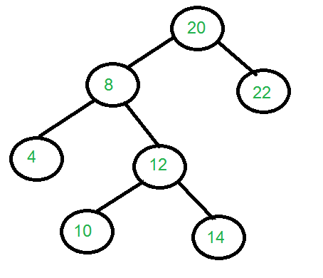
Solution:
/* Recursive function to print all the nodes at distance k in
tree (or subtree) rooted with given root. */

void printkdistanceNodeDown(Node node, int k)
{
// Base Case
if (node == null || k < 0)
return;

// If we reach a k distant node, print it
if (k == 0)
{
System.out.print(node.data);
System.out.println("");
return;
}

// Recur for left and right subtrees
printkdistanceNodeDown(node.left, k - 1);
printkdistanceNodeDown(node.right, k - 1);
}

// Prints all nodes at distance k from a given target node.
// The k distant nodes may be upward or downward.This function
// Returns distance of root from target node, it returns -1
// if target node is not present in tree rooted with root.
int printkdistanceNode(Node node, Node target, int k)
{
// Base Case 1: If tree is empty, return -1
if (node == null)
return -1;

// If target is same as root. Use the downward function
// to print all nodes at distance k in subtree rooted with
// target or root
if (node == target)
{
printkdistanceNodeDown(node, k);
return 0;
}

// Recur for left subtree
int dl = printkdistanceNode(node.left, target, k);

// Check if target node was found in left subtree
if (dl != -1)
{

// If root is at distance k from target, print root
// Note that dl is Distance of root's left child from
// target
if (dl + 1 == k)
{
System.out.print(node.data);
System.out.println("");
}

// Else go to right subtree and print all k-dl-2 distant nodes
// Note that the right child is 2 edges away from left child
else
printkdistanceNodeDown(node.right, k - dl - 2);

// Add 1 to the distance and return value for parent calls
return 1 + dl;
}

// MIRROR OF ABOVE CODE FOR RIGHT SUBTREE
// Note that we reach here only when node was not found in left
// subtree
int dr = printkdistanceNode(node.right, target, k);
if (dr != -1)
{
if (dr + 1 == k)
{
System.out.print(node.data);
System.out.println("");
}
else
printkdistanceNodeDown(node.left, k - dr - 2);
return 1 + dr;
}

// If target was neither present in left nor in right subtree
return -1;
}

